

LiFE FRONTIER ENGAGEMENT

DEPARTMENT OF COMPUTER SCIENCE

PROJECT TITLE: WEBSITE FOR MADURAI SEVASHARAM

By

REGISTER NUMBER NAME

19IFTE039 B.SHANANTHA
19IFTE007 K.ASHWINI
19IFTE008 J.DEEPIKA
19IFTE009 R.DEEPTHISREE
19IFTE047 K.YUVASRI

PROJECT REPORT - 2022

DECLARATION

We do hereby declare that this project titled “WEBSITE FOR MADURAI SEVASHARAM” has been originally done under the guidance of Ms. E. Sheeba Sugantharani M.C.A., M.Phil., (Ph.D.). Assitant professor, Department of Computer Science , Lady Doak College , Madurai for the partial fulfilment of the requirements for the award of the degree of Bachelor of Science in Information Technology is a record for our original work.We further declare that this record or any Part of this has not been submitted elsewhere for any other degree.

Station: Madurai

Date:26-05-2022
Signature of project students

Shanantha.B (19IFTE039)
Ashwini.K (19IFTE007)
Deepika.J (19IFTE008)
Deepthi Sree.R (19IFTE009)
Yuvasri.K (19IFTE047)

CERTIFICATE

This is to certify that the LiFE project entitled “Website for Madurai Sevasharam” is the certified and bonafide work of Shanantha.B (19IFTE039), Ashwini.K (19IFTE007), Deepika.J (19IFTE008), Deepthi Sree.R (19IFTE009), Yuvasri.K (19IFTE047) in partial fulfillment for the degree of Bachelor of Science in Information Technology carried out by them under my guidance and supervision in the Department of Computer Science, Lady Doak College, Madurai-2 in the academic year 2021-2022.

HEAD OF THE DEPARTMENT PROJECT GUIDE

EXTERNAL EXAMINER INTERNAL EXAMINER

ACKNOWLEDGEMENT

At times our own light goes out and is rekindled by a spark from another person. Some of such people who rekindled the spark within us whenever the flame died out of hope are to be
given a special mention here.
First and foremost, praise and thanks to the God, the Almighty, for his shower’s
blessings throughout our project work to complete the project successfully.
We express our special gratitude to our respected Principal and Secretary
Dr . Christianna Singh, M.A., M.Phil., P.G.D.C.A.,( Ph.D.), for providing us the opportunity to
exhibit out talents in our LiFE project.
We are thankful to Dr . N. Jayachandra, M.Sc., M.Phil., (Ph.D.), Head and
Associate Professor, Department of Computer Science for her constant motivation and being
the best guide provided encouragement in all our academics activities.
We are extremely grateful to our Coordinator of B.sc Information Technology
Dr . T.R. Siva Priya M.C.A., M.Phil., (Ph.D.), Associate Professor for providing us a good
platform to prove our talents.
We are thankful to Ms. E. Sheeba Sugantharani M.C.A., M.Phil., (Ph.D.),
Department of Computer Science for guiding and supporting us throughout this project.
We would like to thank all other Faculty members in the Computer Science
Department to provide us with knowledge in various subjects of our course and
encouragement given to us. We express our sincere thanks to our community partner
“MADURAI SEVASHARAM”, for their kind cooperation throughout our entire project.
Finally, we thank all our family members and friends who always support us
in every walk of our life and have been the backbone for us to stand in the place we stand
now.

ACCEPTANCE CERTIFICATE

COMPLETION CERTIFICATE

ABSTRACT

The Web based project is done for the community The Madurai Sevasharam.“Website for Madurai Sevasharam” is the name of the project. The Madurai Sevasharam, is a voluntary charitable institution that has established home for homeless and destitute girl children. The main goal of Madurai Sevasharam is to reach out destitute girls and women from the underprivileged sections of society across urban and rural areas and focuse on providing education and care for these destitute girls and women.
They provide all-round support to these groups for education and empowerment. We have developed a website to ensure global access that full-fills the requirements of Madurai Sevasharam. This website can be accessed by anyone who are interested to donate for the community in the form of food, cash or essential needs and who wish to join as students in the community.
The donors who wish to donate for Madurai Sevasharam can fill the donation form and the members of the Community will contact the donors when in need of donations. Further, anyone who wishes to join as a new student in Madurai Sevasharam can fill out the Registration form and the admin will notify the request and contact them to join in the Sevasharam. We have developed the website using PHP as a frontend software and MySql as the backend software.
To uplift the community we have given provision for the volunteers and donors to fill the forms of donation or registration so that the database can be maintained at the backend and the admin can view list of volunteers and donors.
The admin can login with their username and password. The admin can only login and view the registration and donation details. Admin has the provisions to save the details, delete the details and edit the details of the donors.

GROUP 6_3IT URKUND REPORT

CONTENT

S.NO | TITLE | PAGE.NO
1 | INTRODUCTION  - COMMUNITY PROFILE
2 | REVIEW OF LITERATURE
3 | METHODOLOGY
4 | RESULTS AND DISCUSSIONS
5 | RECOMMENDATIONS
6 | CONCLUSION
7 | APPENDIX
8 | REFERENCES

INTRODUCTION

1.1 COMMUNITY PROFILE

The Community we have chosen for our project is Madurai Sevashram. Madurai Sevashram is a non profit organization involved in helping needy female children a home, education and life skills. It is a voluntary registered non-governmental charitable Institution for destitute children and women. It reaches out to destitute girls and women from the underprivileged sections of the society across urban and rural areas.
Founded in 1956, By TVS Soundaram Ramachandram provides all round support to these groups for education and empowerment. Inspired by TVS Charity, TVS Soundaram Ramachandram. They also helped abandoned women, female children by uplifting them through various vocational, educational and personality grooming workshops.
Located at old Natham road,Madurai Sevashram at present remains as a home for little female children amongst the age group of eight to nineteen. Currently with the help of the members of the nearby rotary club, Sevashram has 10 staffs who help in the overall functioning of the Ashram. At present the Ashram is providing education and is being a home for 46 forty six girl children.

  - EXISTING AND PROPOSED SYSTEM

EXISTING SYSTEM:
At present The Madurai Sevashram community get very less funds as donation and they also have only a small number of students residing in the ashram. They do not have much exposure to donations and admission of students as many people do not know about the community. The community is also in need of donors as they receive less donation funds and only the repeated donors provide donation funds and goods. The community also stores the details of the donors and new applicants manually which leads to problems in accessing the information. Incase of any emergency they do not have any new donors to contact immediately during the times of need. Only forty-six students are present in the community due to lack of exposure of the community.

PROPOSED SYSTEM:
The system we proposed is a full stack website for the community named as “The Website for Madurai Sevashram” project. The website will provide more exposure and have the essential features for accepting donations and new applicants for the community. The user can fill up the donation form present in the website if they want to donate funds or goods to the community. The user can also fill up the new student registration form to apply for accommodation in the community. The Administrators have the option of editing, updating and deleting the donation form and student registration form details. The administrators also can update and edit the contents of the website. This website will store the donor applicant details and student registration form details in the database so that the administrator can access these data easily anytime in the future . This website will act as a bridge between the public and serve as a solution to the organization for donation and admission purposes. The website will also provide a connection between the public and the organization. We also proposed to provide E-content for the community as they requested for animated videos and pdf’s for easy learning which we posted in our blog.

BENEFITS OF THE PROPOSED SYSTEM:

- Users can donate to the community by filing up the donation form.
- Users can register the students for accommodation in the community for people who are in need and if they are in need.
- The Administrator can view, edit, update, delete and contact the donation application and student registration application entries in the database
- The Administrator can also update and edit the contents of the website.
- The Website provides easy access to the donor details and student registration details.

  - MODULES DESCRIPTION

E-CONTENT:
We created e-content for the community students as the community had requested us to create animated videos and documents related to academics and motivational videos. We created animated videos on topics of Social Science and English according to the standard the students study in. We also created content specifically in English as the community staff said that the students are not confident in English and they would like to learn more about the basics of English. Hence we posted videos and contents of basic English grammar pdf and other general knowledge contents in pdf. We also created motivational animated videos for the students which they can view during examination days and when they are in need of motivation. . We created subject related videos for standards 9th,10th,11th and provided e-content for the organization by creating a blog for providing e-books for std 3rd and 4th to the organization .We handed the videos and pdf’s to the community And later posted the pdf’s we created for academics in a blog page and the animated videos related to academics and motivational videos we created on an Youtube channel and handed it over to the community.

HOME:
The Homepage is the heart of the website and gives life to the website. It is the most important part of the website as it gives the public an overall impression of the community and helps to connect with the people. The homepage gives an overview of the services and features provided in the website. The homepage consists of the Madurai Sevashram Logo, About us, Location and Contact, Gallery, Staff Administrator Login, Donor Form, Student Registration Form. All of the other modules are visible on the home page, as well as the community's mission and vision. The Homepage footer contains the location and contact details of the Madurai Sevashram.

ABOUT US
The about us page gives the users an overview about the Community and the services provided by the community, It acts as the spine of the website. The about us page describes about the Madurai Sevashram, as well as the community leader, founder and the services they offered in the past.

GALLERY:
The gallery page gives an insight of the community to the users. The snapshots present in the gallery of the website is which helps the user to picture how the community is present. It creates a vision of the community to the user. It also helps in proving the authenticity of the community to the user and makes the user aware of the community’s presence. This tab is designed to display photos from community events, and community awareness programmes. Anyone can access and see the images. Images of the community and community events are posted in this page. A small description of the images is visible when the mouse is hovered on the images present in the gallery.

DONATION FORM:
The donation form is one of the main purposes of the website. This page helps the community to get new donors and store the donor details. The users can enter their details such as their Name, Age, Phone Number, Contact details, Donation Details in the donation form and the community will contact the donor later.

STUDENT REGISTERATION FORM:
This page helps the users to apply to join the community. Users can either apply the form if they are in need or apply the form for the people who are in need of support. The users need to provide details such as their Name, Parent/Guardian details, Reason for joining the community and submit the form for the admission in the community. The users can join Madurai Sevashram by inputting their information upon registration and the community will contact the applicant later.

LOCATION AND CONTACT PAGE:
This page contains the location and contact details of the community. This page helps the users to communicate with the community easily and provides the necessary information for contacting the community.

ADMIN LOGIN:
The Administrator can login into this page for viewing the database of the donation and Student registration form datas. This page gives the admin authority to delete, update, and add donor and applicant information. Only the administrator has access to the donor and applicant list, which includes the details of applicants and donors and their contact information. The Administrator can view, edit, update, delete and contact the donation application and student registration application entries in the database.The Administrator can also update and edit the contents of the website. The Administrators have the option of editing, updating and deleting the donation form and student registration form details. The administrators also can update and edit the contents of the website. This website will store the donor applicant details and student registration form details in the database so that the administrator can access these data easily anytime in the future

1.4 AIM, OBJECTIVES, SCOPE, LIMITATIONS, HYPOTHESIS, SIGNIFICANCE

AIM AND OBJECTIVES:
The main objective of the “WEBSITE FOR MADURAI SEVASHARAM” project is to develop a web application platform which will act as a bridge between people and the organization for donation and admission purposes.The main aim of our project is to create an web application for the community to provide awareness about the community.
The main objectives of the proposed application include creating a youtube channel for motivational videos and subject videos for std 9th,10th,11th providing e-content for the organization,creating a blog for providing e-books for std 3rd and 4th to the organization.

SCOPE:
Our project will bring more awareness about Madurai Sevashram in a national and international level.As any person irrespective of the place and time zone they reside can view our website at their disposal.By getting awareness in a web platform our community can reach many people who are ready to support them and many people who are in need of a home and education can join Madurai Sevashram by our online web application.We are also sure that the organization will receive more donations from people coming from various parts of the world by our online donation portal.Many people can also access our Youtube channel and Blog page to view our e-content and hopefully learn something new from the contents we have shared.

LIMITATIONS:
The Madurai Sevashram Website can yield its full result only if the website get’s more reach amidst the internet i.e. only if people get the awareness of such a website existing they can provide donations and even list for admissions. As the scope of our study is to provide a website with computer softwares, we are not meant to use payment gateways in our project since it deals with money and problems can occur in payments. So, Even Though we have created a donation platform by using a form, the only limitation that we think is that the process would have been easier if we had used the payment gateway.

HYPOTHESIS:
We solemnly believe that our project will bring more awareness about Madurai Sevashram to the public.So in turn many girl children who are in need of a home and education can join into Madurai Sevashram by our online portal and We are also sure that the organization will receive more donations from people coming from various parts of the world by our online donation portal.We also hope that the organization makes complete benefit of the youtube videos and e-content and the students of Sevashram get more fluent in English as it was stated by the staffs that the present students were not confident in english.
SIGNIFICANCE OF MODULES:
After interacting with the community members and getting to know about their needs and wants we decided to provide E-Content for the community.The community staff said that the students present in the community faced most difficulties in studying and speaking the english language and hence they requested for more e-contents specific in the subject english and other subjects.We decided to make youtube videos common for all of the students irrespective of the grade they are studying in.We wanted to simplify the syllabus they study by providing videos in more basic topics and make them strong in the basics.The community also requested for e-books of the TamilNadu State Board Syllabus which we handed over to the students.We also made motivational videos for the students to watch them during examination times and to feel motivated.We also posted contents regarding to their syllabus in our blog with simple and understandable topics regarding the basics.

REVIEW OF LITERATURE

2.1 REVIEW OF LITERATURE

We have selected Madurai Sevashramam for our community project. And for this we had searched so many references like previous years projects and documents that are available in our college. We have also referred many websites for the reference, finally all our team members are ok with 'Care Trust' and we decided to take that trust for our website references. We also referred about the modules in that website as well as in google.
We also searched about the software that we are about use for the website and finalized with visual Studio code and the languages that we have chosen are 'Html', 'Css' for front end and for the backend we have chosen 'PhP', 'Sql' and 'Java script'. We referred a lot of YouTube videos for the coding and designing. We discussed about so many references in google meet and considered all members suggestions. We also divided the contents equally and did our project successfully.

METHODOLOGY

3.1 IDENTIFICATION OF COMMUNITY NEEDS

A successful community project first identifies the needs of community and plans effective ways for solutions to satisfy the needs of its community. We assessed them with questionnaire to identify their needs and demands for the welfare of their community and its people. We asked several questions in questionnaire like, whether they want a website for their community, animation videos for children, e-books for children, attendance portal for the students and do they want to create accounts in social media. The community needs told by Madurai Sevasharam are,
1. Website for Madurai Sevasharam
2. Animation videos for children
3. Attendance portal for students for future references.
4. Grammar E-book to improve the English knowledge of their students.
5. Formula pdf for reference for higher secondary students which makes them understand the concepts faster.
6. Admission registration and deletion for collecting the student admission details.
7. Student’s details portal to store details of students in Madurai Sevasharam .
8. Employee application form for employee recruitment of their community.

3.2 SYSTEM TESTING AND IMPLEMENTATION
System testing is defined as testing of a complete and fully integrated software product. System testing is performed on the entire system in the context of a Functional Requirement Specifications (FRC) and
System Requirement Specification (SRS). System Testing tests not only the design,but also the behavior and even the believed expectations of the customer. It is also intended to test up to and beyond the bounds defined in the software or hardware requirements specifications.

TYPES OF TESTING USED IN PROJECT

WHILE BOX TESTING:
White box testing is a testing technique that examines the program structure and derives test data from the program logic or code. The other names of white box testing are clear box testing, open box testing , glass box testing ,logic driven testing testing or path driven testing or structural testing. In white box testing is primarily concentrate on the testing of program code of the systems under test like code structure, branches , conditions , loops. White box testing is also known as code-based testing or structural testing.
UNIT TESTING:
Unit testing is the testing of individual units that falls under the class of white box testing. It often has few inputs and one output. In this project on testing each and every module like
Home Page, About us , Gallery, Contact us, Register, Login page.
INTEGRATION TESTING:
Integration testing is when a set of components is combined to achieve a result. If software and hardware have any relationship, integration testing is used to test the interaction
between them. It might be classified as both white box and black box testing. This testing was done by combining all of the units. This test was carried out with extreme caution. We combined modules like home, about us, contact us, and gallery with no problems, but when it comes to the database (Login, Registration), the alignment becomes a mess. After that, we
fixed it.
VALIDATION TESTING:
The process of evaluating software during the development process or at the end of the development process to determine whether it satisfies specified business requirements. Validation testing ensures that the product actually meets the clients needs. It can also be defines as to demonstrate that the product fulfils its intented use when deployed on appropriate environment.

3.3 INVOLVEMENT OF COMMUNITY PARTNERS

Our community, Madurai Sevashramam , Members cooperated very well with us.
During data collection they never said no or delayed but gave the information immediately and
even helped us arranging the datas according to the respective fields. They also took care of us
while we visited them every time. They took time to show their community and allowed us take
photos of the community.
We sent the questionnaire to the community, they responded in a good way and all the staff
members and the girls stayed in the community filled the questionnaire immediately without any delay .
They have also explained their needs to us until we understood them and also gave us some
advice and ideas for the modules and the registration pages that they wanted.
They also allowed us taking photos with the staff members and the girls in the community.
They never pressured us about the website but gave us many ideas about the website.
After completing the website they gave a very good feedback about the work we have done.
They also appreciated our hard work and the creativity that we have implemented in our project.
They liked the website that we have created for them felt grateful for help we have done for the community.

3.4 DATA COLLECTION METHODS
We have implemented many methods to collect datas from the community. We have used
questionnaire,
google forms
drives and also
In person to collect the datas.
They have also participated well and gave us all the datas on time without any delay.
The most effective data collection method is drive and going in person because we can
interact with them and we can get all the datas that we wanted and also get some ideas from
them.
The datas were collected and used in useful manner that would be a benefit for the
community.

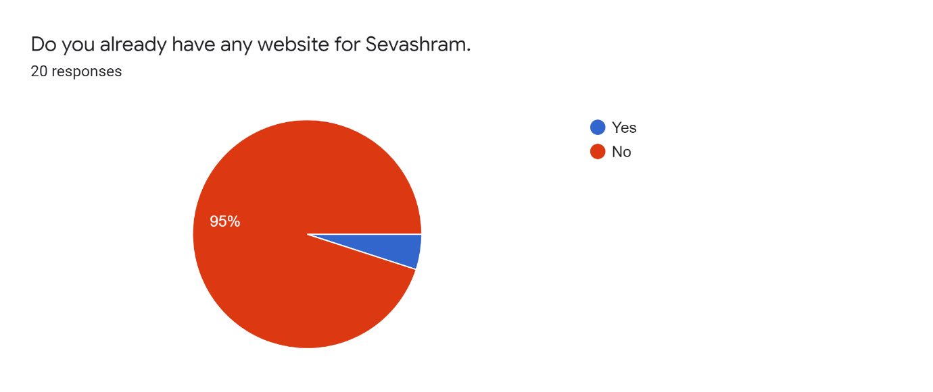
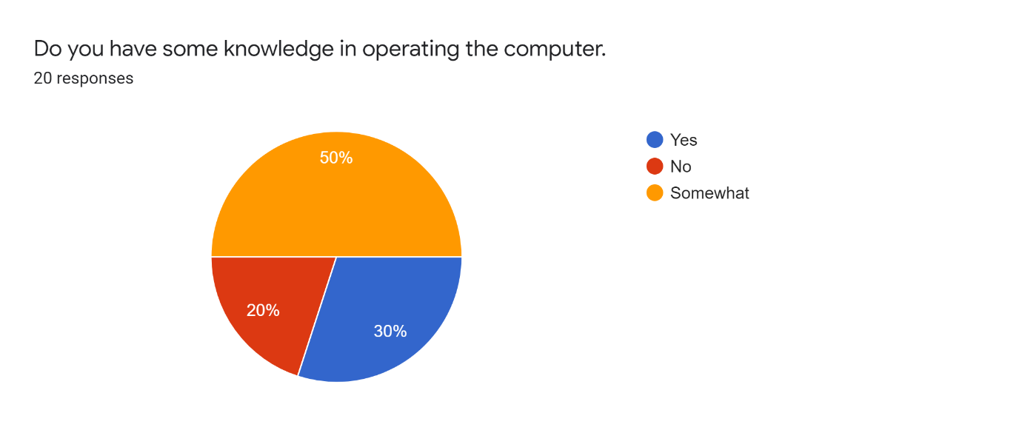
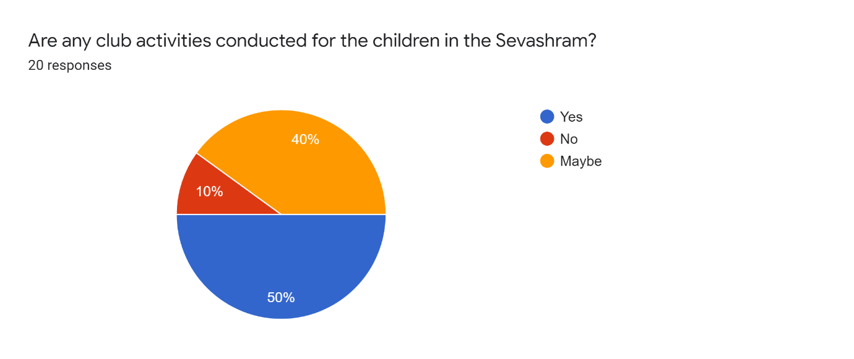
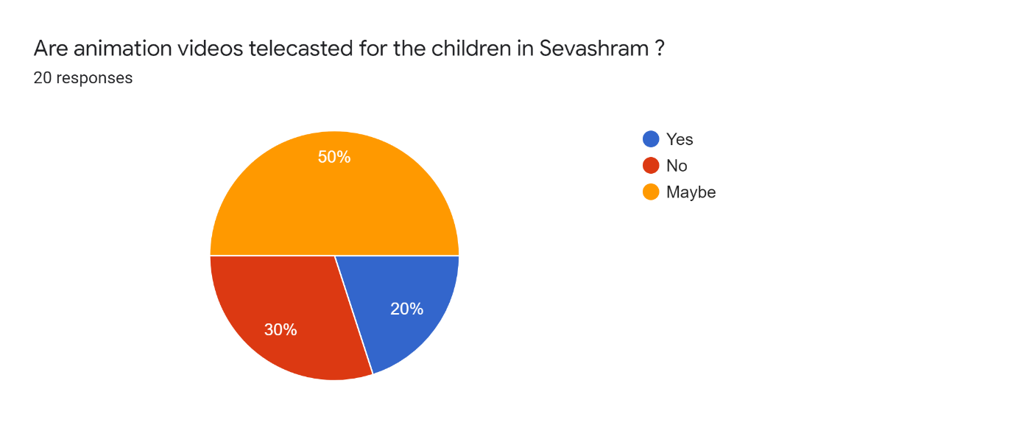
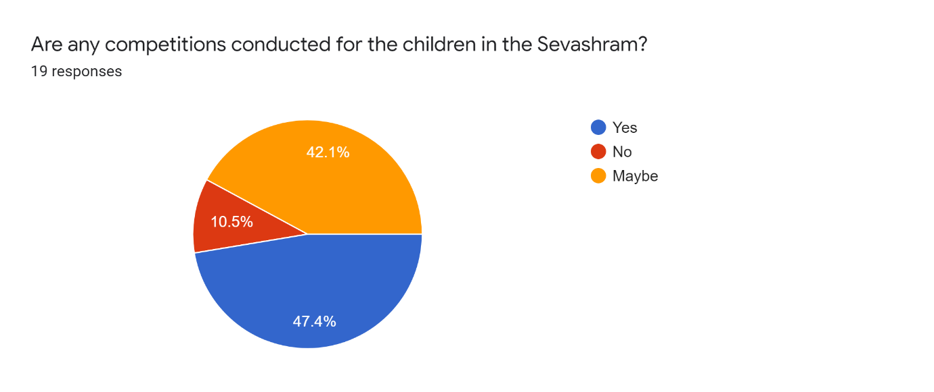
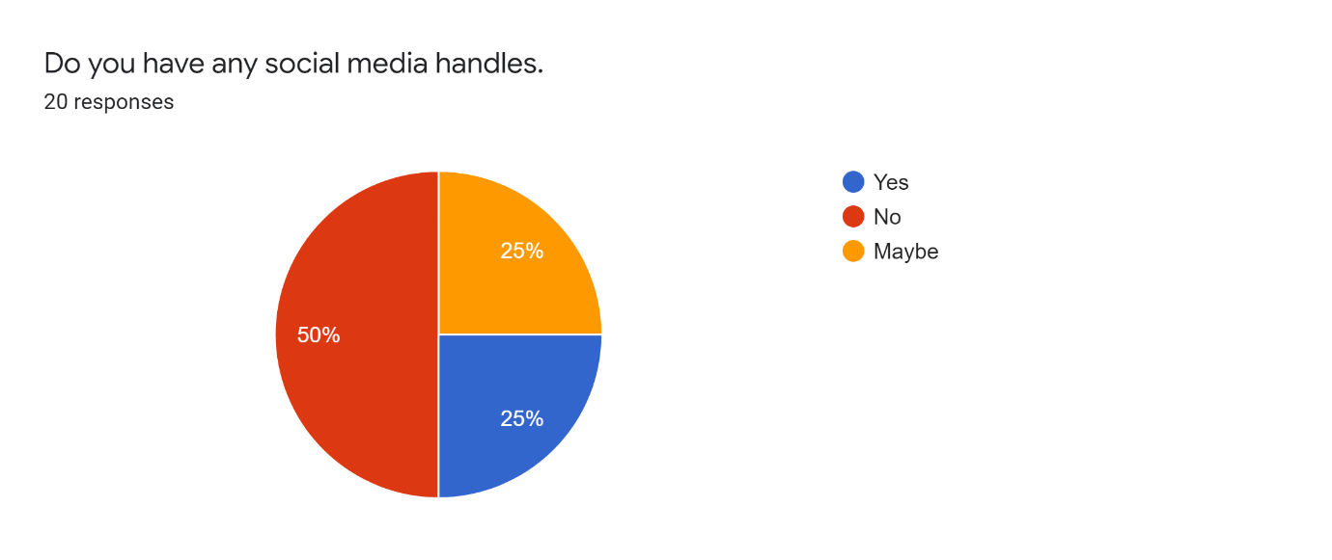

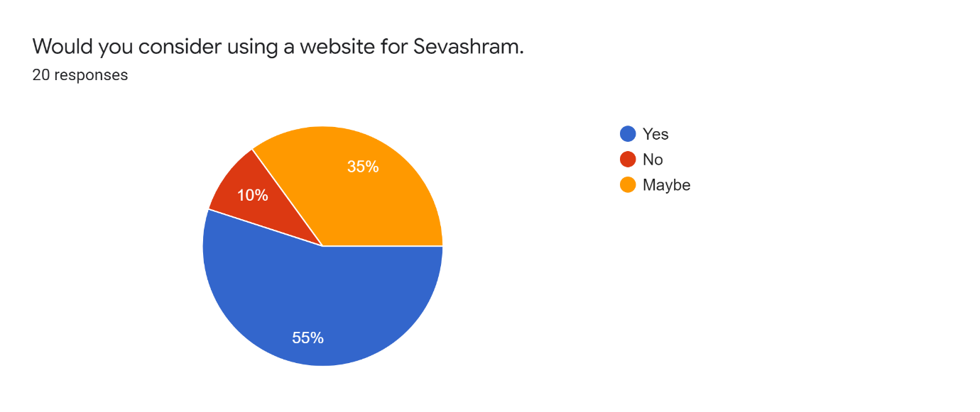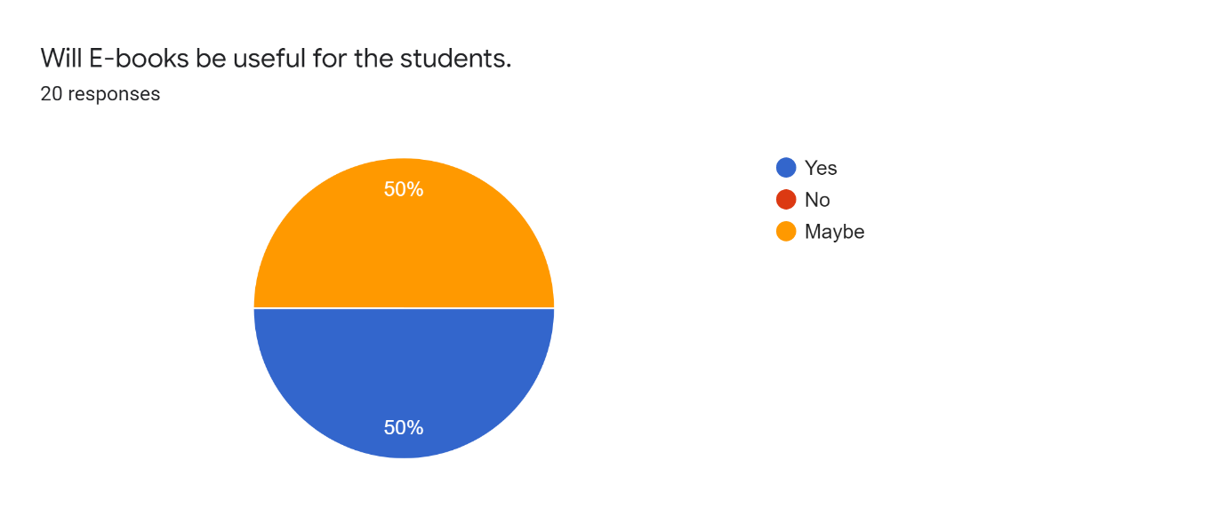
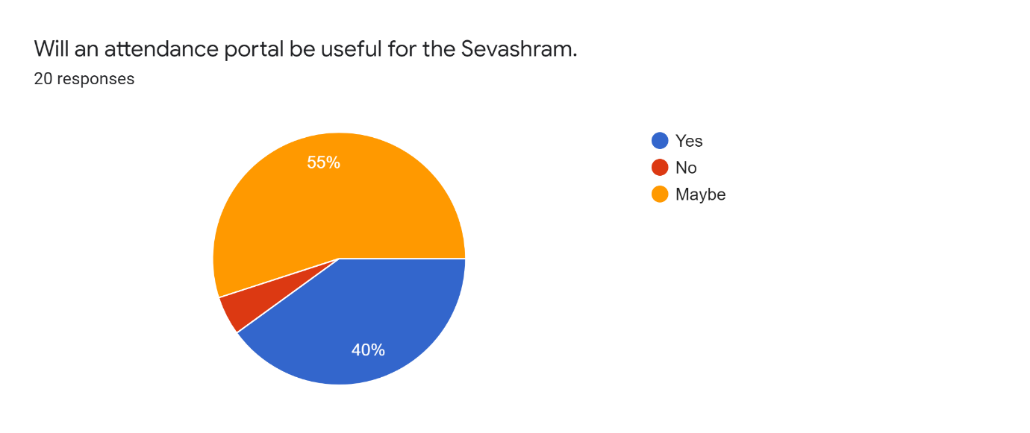

3.5 DATA FLOW DIAGRAM

We implemented data flow diagrams for our community Madurai Sevashram with the modules registration, login and donation page. In the data flow diagram we specified how the details and information of donor/applicant is transferred from the donor/applicant to the admin in the process of registration, login or donation. We have explained the process of how login, registration and donation takes place in the website from applicant/donor to admin.

Level 0 DFD : WEBSITE FOR MADURAI SEVASHRAM
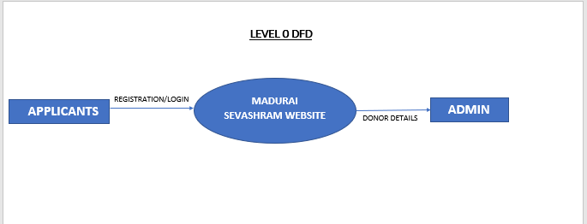
Level 1 DFD: USER REGISTRATION
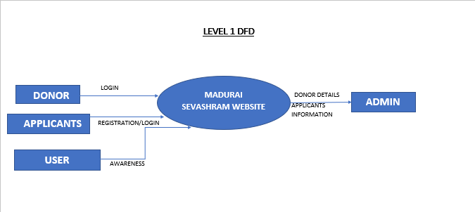
Level 2 DFD: DONOR APPLICATION
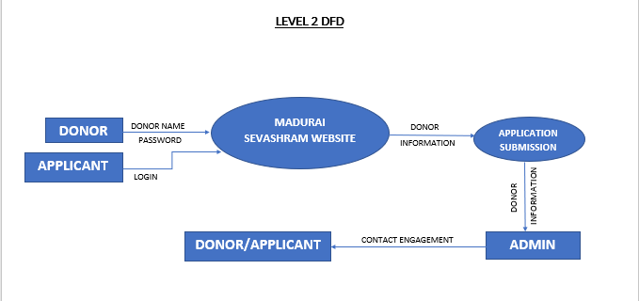
Level 3 DFD: ADMIN LOGIN
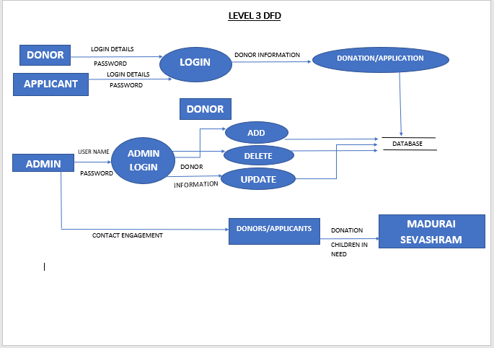

3.6 INPUT AND OUTPUT DESIGN

INPUT DESIGN:
Input design is the process of converting a user – oriented description of input into a computer-based system. Input designs specify the interactive communication between the user and the server. In Admin login page admin needs to longin using the unique username and password to view the database. Admin can view the database of the volunteers and donors who filled the registration and donation form , the admin has the provisions to edit , save, delete and edit the details of the donor’s details in the database. In Registration form , the volunteers who wish to join girl student in the sevasharam can fill out the Registration form ,users can give the details like students name , Guardian/parent’s name, Age, Phone number, address etc and the admin will notify and contact them. In donation form, the donors wishing to donate for Madurai sevasharam can fill out the form users can give the details like Donor name, Address, Contact number etc and the admin notify and contact them when in need.

OUTPUT DESIGN:
Output design exposes an interactive mode with an illustrative manner. Output design displays interactive output, based on the input given by the community member or admin. The registration form and donation forms filled by the users can be accessed by the admin in the admin login page using username and password. The website also contains About page , Contact us/Location page, Gallery page that displays static information of Madurai Sevasharam.

RESULTS AND DISCUSSION

4.1 REFLECTION
This project helped us to gain experimental knowledge in learning things by doing practically. It helps us to develop our knowledge . We gained confidence to face challenges in the society . It also helps us to interact with people outside. We also get new team spirit.
Everything was new to us because this was a long-term web project. Patience, in my opinion, was the most important and necessary aspect in such a long project.Furthermore, communication was an enormously important component.
During this whole course of time while preparing for our project in a team, Our patience level has increased to a great extent. Individually each person might have their own methodology of completing things but when we had to work together as a team we had to get out of our comfort zone and adjust, adhere to the wants of our team. As hectic and tiresome it was at times during the preparation, the experience was completely worth it as we got to acquire more life skills like team management, interpersonal skills, patience , time management , collaboration , communication , problem solving skills and leadership skills.
We improved our problem-solving, software programming, and testing skills by
working on this project. We overcame our shyness and anxiety to interact with others. We
learned how to communicate with and interact with professionals. It enhances our learning
experience and assists us in taking on more tasks.
We also learn about community service. While working on this project, we had a
unique encounter. Many individuals will benefit from our website by receiving blood on
time, knowing more about blood groups, donating blood, and learning more about Madurai
blood donor.

.

RECOMMENDATION

5.1 RECOMMENDATION AND SOLUTION FOR TARGET GROUP:

This is a small non-profit organization, and many people are quite unaware that such an organization exists. This problem can be remedied by placing advertisements on their own website, providing information about their community via WhatsApp groups, Social Media pages. Their service is another key to recognition. Quality service is constantly at its peak. Getting the passed out students of the Ashram to tell about their experience in any social media website might also give them a big reach.

5.2 MEDIA RELATIONS

There are no social media sites for Madurai Sevashram, such as Facebook, Instagram or Twitter. Our community Madurai sevashram have account only in gmail in the network of social media. The official mail id of the community Madurai sevashram is maduraisevashram@gmail.com.. However, the best area to advertise is on social media. On social media, we may find people of different ages who are in need of help or we might find people who can suggest people and help others who are in need of the service by creating awareness. Information spreads quickly thanks to social media. So, if they need donations or want to accommodate many students this will be really beneficial.We have currently created a
YouTube channel for them to upload the animation videos we have done for the students. We truly believe that social media will help in enhancement of their community identification and communication. We also believe that having accounts in social media will greatly help them in all ways. Currently they haven’t specified us for creating any accounts in social media.

CONCLUSION

6.1 CONCLUSION OF OUR PROJECT
Our project “Website for Madurai sevashram” acted as an communication interface between the user and our community Madurai sevashram. The project has been modified and updated according to the requirements of the community. Hence we made sure that our project satisfied and fulfilled the requirements of the community. This project helped the community in various ways such as in their communication between user, admission of people, employment recruitment and storing the student’s attendance and admission details in the database etc.. This project has also cherished our innovative skills, critical thinking, team-work, unity, implementation skills and other valuable assets. We strongly believe that our website done has satisfied the needs of the community and has greatly helped them in meeting their requirements and lifting them to their next level of development.

6.2 FUTURE ENHANCEMENT

The present satisfaction is required for a project, but it is also essential to be mindful of the
future reach . Future enhancement is required Enhancements that can be included in the Charity Support are Orphanages all across India can be included. Notifications via SMS can be done for donation and registration. Education and medical details can be added to children details.On the other hand, today’s technology can eliminate these constraints. The administrator will be able to add data to the website in the future.

APPENDIX

7.1 SAMPLE CODE
HOME PAGE:
DOCTYPE html&gt;
&lt;html lang=&quot;en&quot;&gt;
&lt;head&gt;
&lt;meta charset=&quot;UTF-8&quot;&gt;
&lt;meta http-equiv=&quot;X-UA-Compatible&quot; content=&quot;IE=edge&quot;&gt;
&lt;meta name=&quot;viewport&quot; content=&quot;width=device-width, initial-scale=1.0&quot;&gt;
&lt;title&gt;madurai sevasharam&lt;/title&gt;
&lt;link rel=&quot;stylesheet&quot; href=&quot;css/style.css&quot;&gt;
&lt;/head&gt;
&lt;body&gt;
&lt;header&gt;
&lt;div class=&quot;logo&quot;&gt;&lt;img src=&quot;assets/logo1.png&quot;&gt;&lt;/div&gt;
&lt;div id=&#39;nav&#39;&gt;
&lt;li&gt;&lt;a href=&quot;#&quot;&gt;Home&lt;/a&gt;&lt;/li&gt;
&lt;li&gt;&lt;a href=&quot;about.html&quot;&gt;About &lt;/a&gt;&lt;/li&gt;
&lt;li&gt;&lt;a href=&quot;loc.html&quot;&gt;Contact/Location&lt;/a&gt;&lt;/li&gt;
&lt;li&gt;&lt;a href=&quot;gal.html&quot;&gt;Gallery&lt;/a&gt;&lt;/li&gt;
&lt;li&gt;&lt;a href=&quot;log.php&quot;&gt;Login&lt;/a&gt;&lt;/li&gt;
&lt;/div&gt;
&lt;/header&gt;
&lt;div class=&quot;main&quot;&gt;
&lt;div class=&quot;content&quot;&gt;
&lt;h1&gt;MADURAI SEVASHRAM&lt;/h1&gt;
&lt;h2&gt;&lt;bold&gt;WELCOME TO THE FAMILY&lt;/bold&gt;&lt;/h2&gt;
&lt;h3&gt;&lt;bold&gt;WE ARE SO GLAD TO HAVE YOU HERE!!&lt;/bold&gt;&lt;/h3&gt;
&lt;button onclick=&quot;window.location.href=&#39;reg.php&#39;;&quot;&gt;
REGISTER NOW
&lt;/button&gt;&amp;nbsp;&amp;nbsp;&amp;nbsp;
&lt;button onclick=&quot;window.location.href=&#39;don.php&#39;;&quot;&gt;
DONATE US
&lt;/button&gt;
&lt;/div&gt;
&lt;/div&gt;
&lt;/div&gt;
&lt;/body&gt;
&lt;/html&gt;
*{
margin: 0;
padding: 0;
box-sizing: border-box;
cursor: pointer;

font-family: sans-serif;
}
body{
width: 100%;
min-height: 100vh;
background-color: #344966;
background-repeat: no-repeat;
background-size: 100% 100%;
overflow: hidden;
}
.logo img {
float: left;
height:auto;
width: 150px;
}

header{
display: flex;
justify-content: space-between;
padding: 15px 20px;
color: white;
animation: header 2s ease-in-out;
}

@keyframes header{
0%{
transform: translateY(-100%);
}
}
#nav li{
display: inline-block;
margin: 10px 20px;
font-weight: 600;
}
#nav li a{
text-decoration: none;
color:white;
font-family:Arial;
font-weight:bold;
}

#nav li a:hover{
color:#fbb13c;

}
.main{
width: 100%;

display: flex;
text-align: center;
}
.content{
width: 50%;
margin-top: 15px;
margin-left: 5%;
color: white;
overflow: hidden;
animation: content 2s ease-in-out;
text-align: center;
}
@keyframes content{
0%{
opacity: 0;
transform: translateX(-50%);
}
}
.content h1{
font-size: 80px;
margin-bottom: 1%;
letter-spacing: 8px;
text-align: center;

}

.content h2{
font-size: 25px;
margin-bottom: 3%;
font-family: Verdana, Geneva, Tahoma, sans-serif;
text-align: center;
}

.content h3{
font-size: 25px;
margin-bottom: 3%;
font-family: Verdana, Geneva, Tahoma, sans-serif;
text-align: center;
}

span{
color: yellow;
}
.content p{
font-size: 20px;
margin-bottom: 3%;
font-family: Verdana, Geneva, Tahoma, sans-serif;

}
button{
padding: 15px 30px;
background: transparent;
color: white;
font-size:17px;
border-radius: 10px;
}
button:hover{
background: #fbb13c;
}
.content{
width: 100%;
text-align: center;
}
.content{
width: 100%;
/* text-align: center; */
}
.content h1{
margin-bottom: 5%;
}
.content h3{

margin-bottom: 5%;
}
.content p{
margin-bottom: 5%;
}
ABOUT PAGE:
&lt;!DOCTYPE html&gt;
&lt;html&gt;
&lt;head&gt;
&lt;meta charset=&quot;utf-8&quot;&gt;
&lt;meta name=&quot;viewport&quot; content=&quot;width=device-width, initial-scale=1.0&quot;&gt;
&lt;link rel=&quot;stylesheet&quot;
href=&quot;https://pro.fontawesome.com/releases/v5.10.0/css/all.css&quot;&gt;
&lt;link rel=&quot;stylesheet&quot; type=&quot;text/css&quot; href=&quot;about.css&quot;&gt;
&lt;title&gt;About us&lt;/title&gt;
&lt;/head&gt;
&lt;body&gt;
&lt;section&gt;
&lt;div class=&quot;about-us&quot;&gt;
&lt;h1&gt;ABOUT US- MADURAI SEVASHRAM&lt;/h1&gt;
&lt;div class=&quot;wrapper&quot;&gt;
&lt;div class=&quot;content&quot;&gt;

&lt;h3&gt;A VOLUNTARY REGISTERED CHARITABLE
INSTITUTION FOR THE DESTITUTE CHILDREN AND WOMEN IN
MADURAI&lt;/h3&gt;
&lt;p&gt;Madurai sevashram rooted in 1956 by honourable TVS
Soundaram ramachandran sir in Madurai, is a Voluntary Registered non-
governmental charitable institution for helping destitute children and women in
madurai. We are reaching out and helping destitute girls and women from the
underpriviliged sections of society across urban and rural areas in their education
and shelter. We have also helped abandoned women by uplifting them through
various vocational,educational and personality grooming workshops! Madurai
sevashram provides all-round support to these people by &quot;Education,
Empowerment and Shelter&quot;. &lt;/p&gt;
&lt;div class=&quot;social&quot;&gt;
&lt;a href=&quot;&quot;&gt;&lt;i class=&quot;fas fa-
envelope&quot;&gt;&lt;/i&gt;maduraisevashram@gmail.com&lt;/a&gt;

&lt;a href=&quot;&quot;&gt;&lt;i class=&quot;fas fa-phone-alt&quot;&gt;&lt;/i&gt;0452-
2641537&lt;/a&gt;

&lt;/div&gt;
&lt;/div&gt;
&lt;div class=&quot;image-section&quot;&gt;
&lt;img src=&quot;lad.jpg&quot;&gt;
&lt;p&gt;HONOURABLE SECRETARY OF MADURAI
SEVASHRAM- &quot;MALATHI PITCHAIMANI&quot; &lt;/p&gt;
&lt;/div&gt;
&lt;/div&gt;

&lt;/div&gt;
&lt;/div&gt;
&lt;/div&gt;
&lt;/div&gt;
&lt;/section&gt;
&lt;/body&gt;
@import
url(&#39;https://fonts.googleapis.com/css2?family=Poppins:wght@200;300;400;500;&amp;d
isplay=swap&#39;);
*{
margin:0px;
padding:0px;
box-sizing: border-box;
line-height: 1.5;
font-family: &#39;Poppins&#39; , sans-serif;
}
body{
width: 100%;
min-height: 100vh;
background-color: #ddd;
}
.about-us{
width: 100%;

}
.about-us h1{
text-align: center;
font-size: 40px;
color:#2b9ec2;
text-transform: uppercase;
letter-spacing: 1.5px;
margin-top: 50px;
}
.about-us h1::after{
content:&quot;&quot;;
height: 5px;
width: 200px;
background-color:#2b9ec2;
border-radius: 10px;
display: block;
margin:auto;
}
.wrapper{
padding:0px 60px;
margin:60px auto;
}
.content{

width: 60%;
float: left;
text-align: left;
padding: 0px 30px;
}
.content h3{
color:#222;
letter-spacing: 1px;
}
.content p{
font-family: sans-serif;
font-size: 17px;
color:#3d3d3d;
margin-top: 20px;
}
.content .social{
margin-top: 30px;
margin-left: 15px;
text-align: left;
}
.content .social a{
text-decoration: none;
color: #222;

font-size: 20px;
}
.content .social i{
height: 40px;
width: 40px;
background-color: #fff;
border: 1px solid #222;
border-radius: 50%;
text-align: center;
line-height: 40px;
}
.image-section{
width: 40%;
float:right;
object-position: center right;
padding:0px 30px;
font-size: large;
font-weight: 900;
font-style: normal;
color: black;
}
.image-section img{
max-width: 100%;

height: auto;
left: 50%;
top: 50%;

}
@media screen and (max-width: 900px){
.about-us{
width: 100%;
padding-top: 20px;
}
.about-us h1{
font-size: 32px;
}
.content{
width: 100%;
float: none;
}
.content .social{
margin-top: 30px;
text-align: center;
}
.content .social a{
font-size: 21px;

}
.image-section{
float: none;
width: 100%;
margin-top: 25px;
}
}

SAMPLE OUTPUT

PHOTOGRAPH OF TEAM 6 WITH COMMUNITY
We visited the community Madurai sevashram and took group photos with them. We explained our project done to the faculties of Madurai sevashram and we also updated about the modifications and current-updates done in the website according to their requirements and satisfaction to them. We also made sure that they were satisfied with their requirements in the website and overall project done by us.
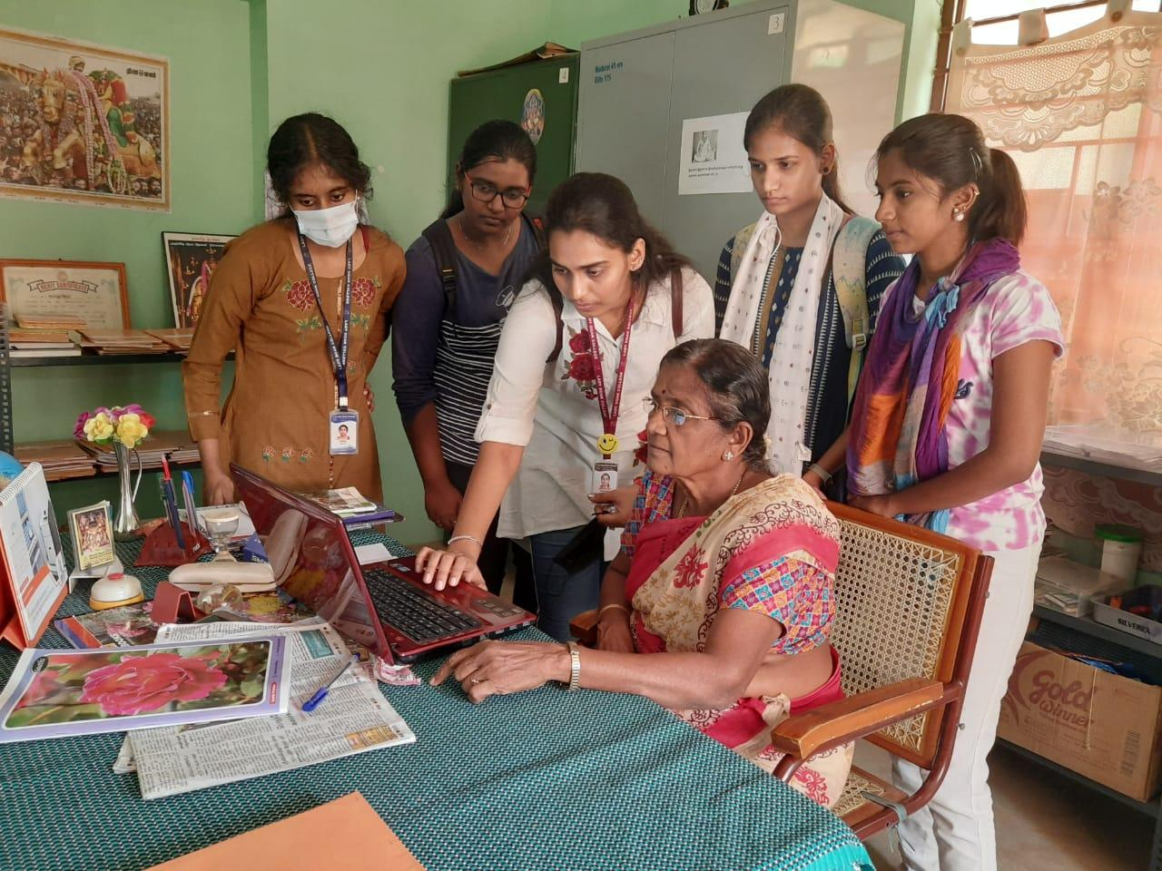
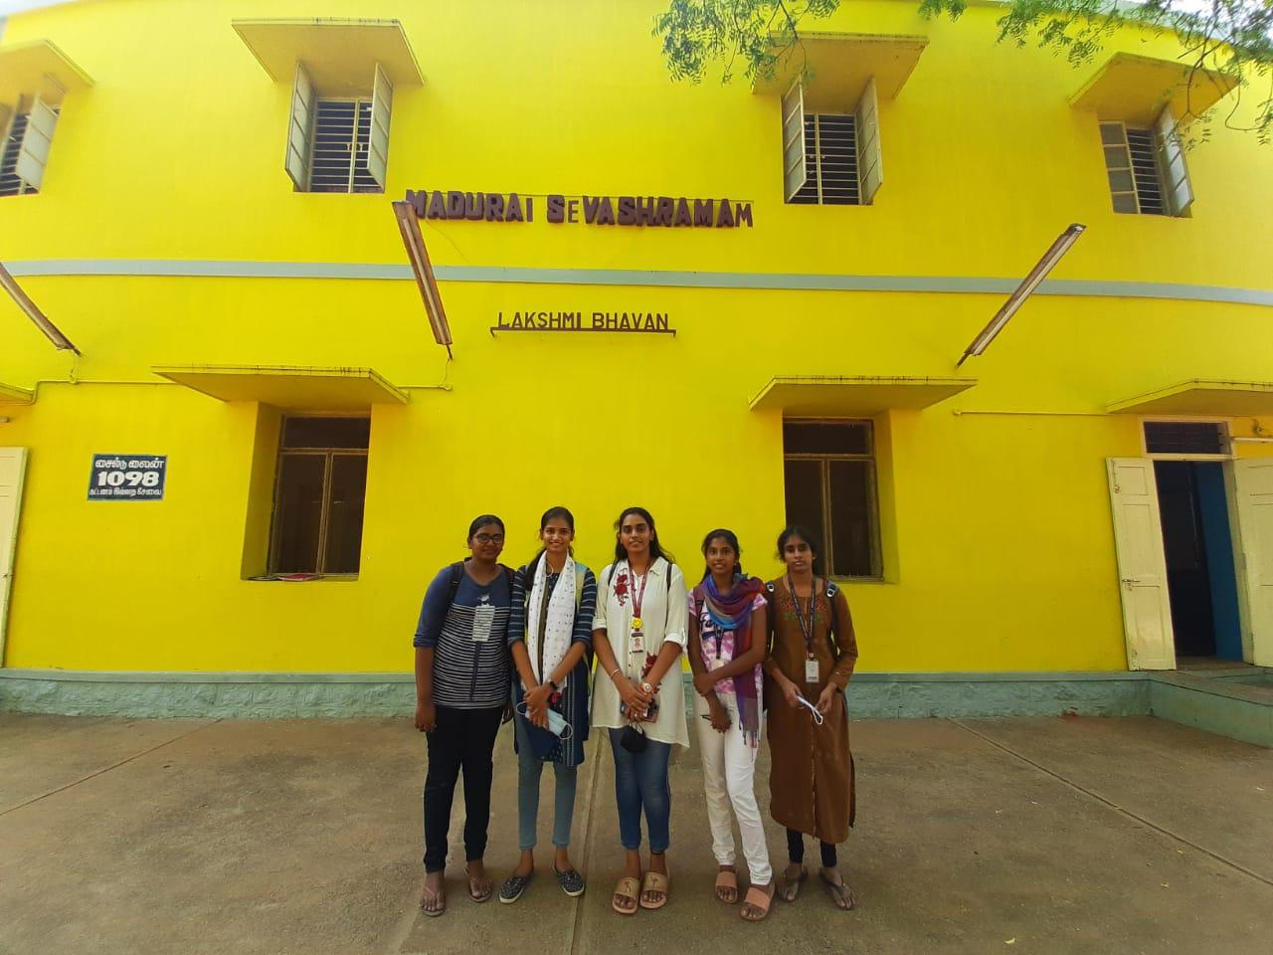
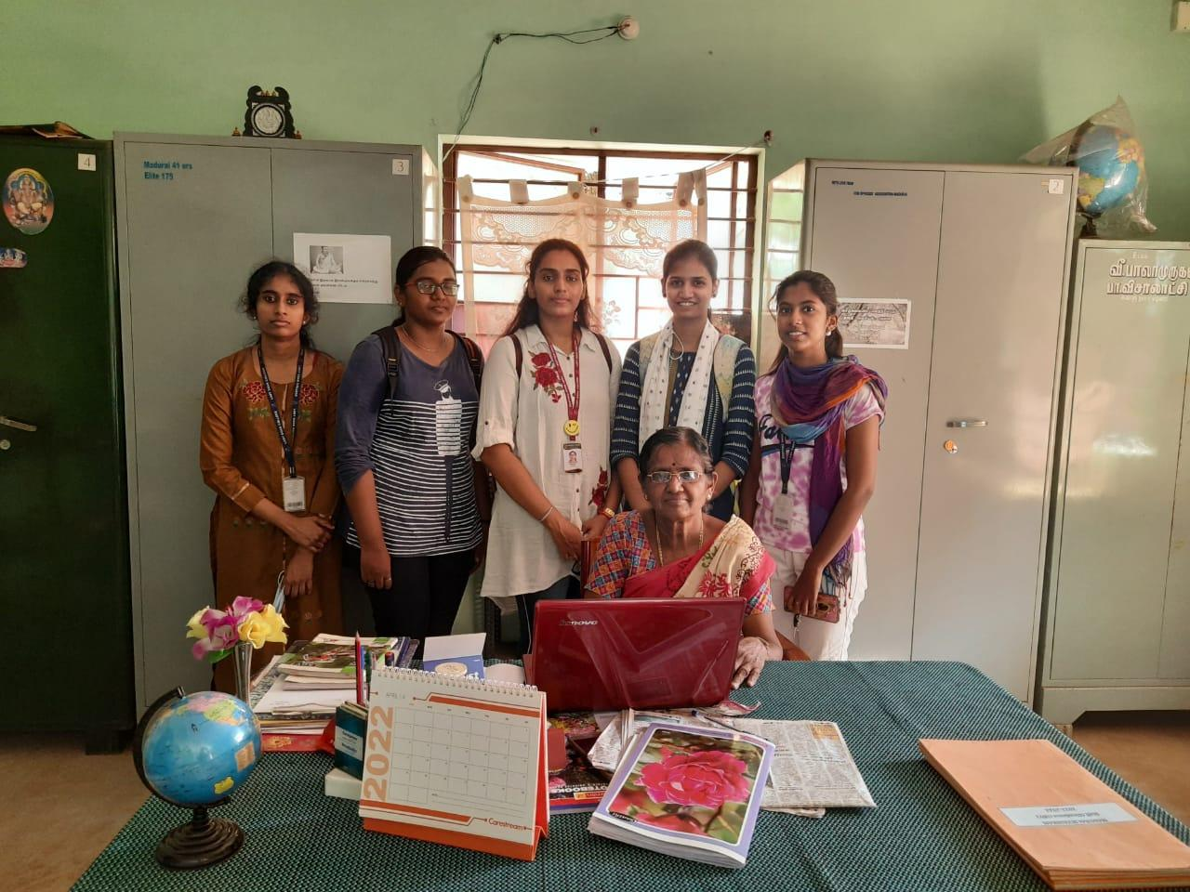
LOCATION OF MADURAI SEVASHARAM

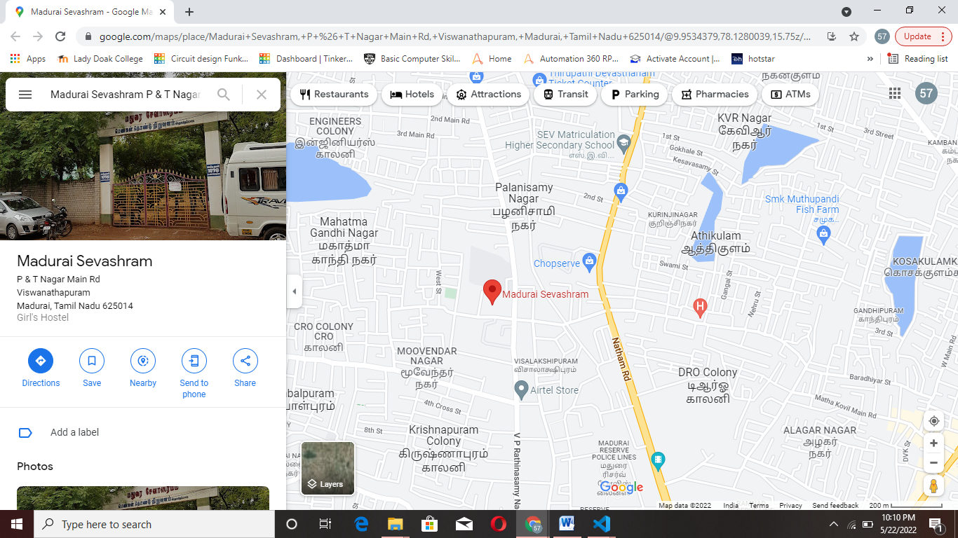

REFERENCE

- 1.https://www.w3schools.com/w3css/defaulT.asp
- 2.https://www.tutorialspoint.com/mysql/index.htm
- https://www.tutorialspoint.com/css/index.htm
- https://www.geeksforgeeks.org/html/
- https://www.w3schools.com/tags/tag_select.asp
- https://fontawesome.com/

8.2 BIBLOGRAPHY

